To Change A Quote To An Order:
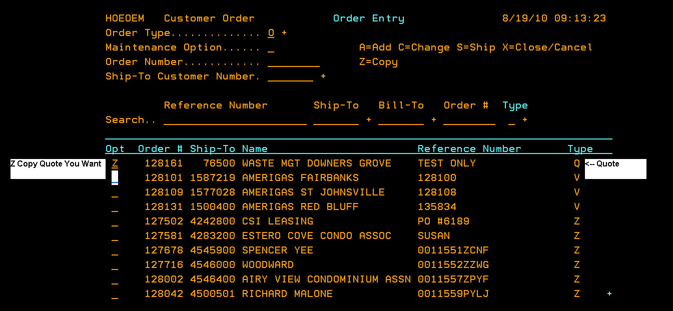

After Changes, F11 To Accept And Proceed
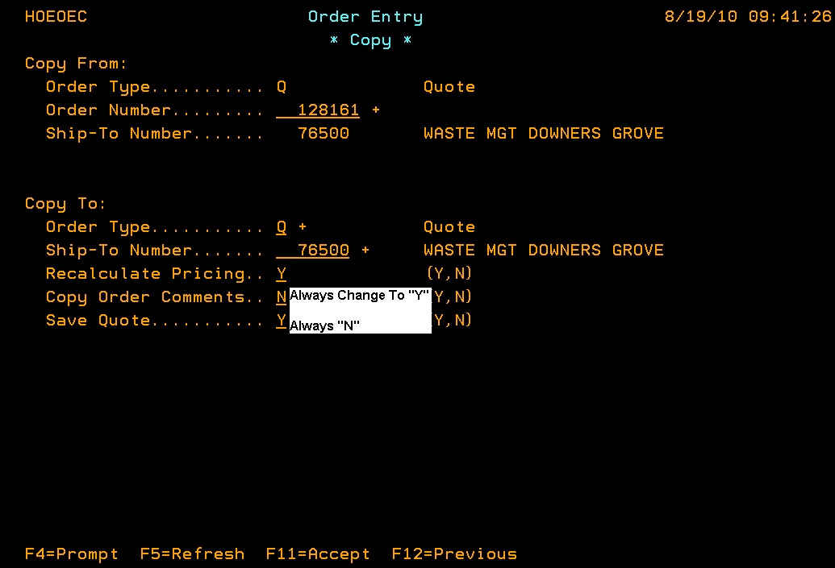

ALL information that was entered into the quote on EACH screen will carry over. Be sure to verify and change anything that may be required.
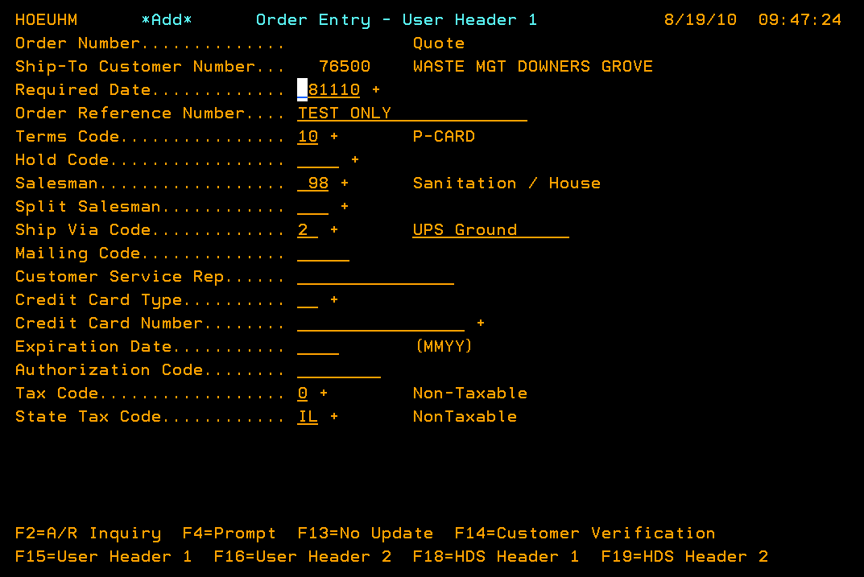
See IMPORTANT note below. This is a glitch in our custom program (or Harris) that only happens when we enter Quotes/Orders into EIP. 